Carey Hack

WGU Data Analyst – Udacity

February 10, 2021

Test a Perceptual Phenomenon / 3rd Attempt

1. What is our independent variable? What is our dependent variable?

The independent variable for the given task is the word and colors associated with each word. The dependent variable will be the time taken identifying words and/or colors.

1. What is an appropriate set of hypotheses for this task? What kind of statistical test do you expect to perform? Justify your choices.

The hypothesis for this task will be as follows with i representing incongruent data and c representing congruent…

* Null hypothesis or HO represents no change between congruent and incongruent.

µi - µc = 0

* Alternative hypothesis or Ha represents change either positive or negative in the time taken between congruent and incongruent.

µi - µc  0, µi - µc > 0, µi - µc < 0

The data seems to show a rise in times taken for incongruent testing but to be certain a dependent two-tailed t-test for paired samples will be performed to identify an increase or decrease in the amount of time taken to answer. The data is paired by one tester being administered two tests to determine any variability in time between the congruent and incongruent test set. It is assumed the data has been randomly sampled from the population of interest and that the data variables follow a normal distribution.

|  |  |  |
| --- | --- | --- |
|  | Congruent | Incongruent |
| Maximum | 22.33 | 26.28 |
| 3rd Q | 16.59 | 24.37 |
| Median | 14.36 | 21.02 |
| 1st Q | 11.53 | 18.67 |
| Minimum | 8.63 | 15.69 |
| Variance | 12.14 | 22.05 |
| Stan Dev $σ$ | 3.56 | 4.80 |

1. Report some descriptive statistics regarding this dataset. Include at least one measure of central tendency and at least one measure of variability.

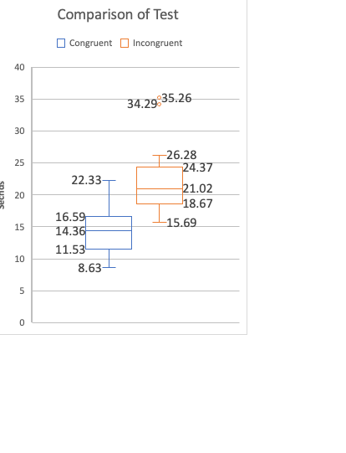

1. Provide one or two visualizations that show the distribution of the sample data. Write one or two sentences noting what you observe about the plot or plots.

There are two outliers within the incongruent data set resting at 34.29 and 35.26. This chart also shows that it is likely that a difference between congruent and incongruent times will be found.

1. Now, perform the statistical test and report your results. What is your confidence level and your critical statistic value? Do you reject the null hypothesis or fail to reject it? Come to a conclusion in terms of the experiment task. Did the results match up with your expectations?

$α$ = 0.05 Df = 23 Confidence Interval = 9.97 to 5.96

t*critical = -2.064 +2.064 t score = 8.02 Cohens d = 1.67

Point estimate/Difference from mean = 7.96

With a t score of 8.19 the null hypothesis will be rejected. These findings are significant in that a substantial increase in time needed to answer incongruent questions is shown to be true and reliable. From the Comparison of Test chart, an increase in time needed was expected and the experiment has shown as such.